

REPORT
ANNUAL

2008/09

7-1715 St. James Street
Winnipeg, Manitoba R3H 1H3

TABLE OF CONTENTS

MINISTER’S LETTER OF TRANSMITTAL 3
DEPUTY MINISTER’S LETTER OF TRANSMITTAL 4
CHIEF OPERATING OFFICER’S LETTER OF TRANSMITTAL 5
BACKGROUND 6
STRUCTURE FOR OPERATIONS 7
MDA MISSION STATEMENT 9
ORGANIZATIONAL GOALS 9
ORGANIZATIONAL VALUES 9
AGENCY PRODUCTS 10
AGENCY SERVICES 10
MARKET SEGMENT INFORMATION 11
WAREHOUSE PRODUCTS – DISTRIBUTION INFORMATION 12
2008/09 PROJECTS AND ACTIVITY STATUS HIGHLIGHTS 12
1. Human Resources Overview 12
2. Marketing and Communications Overview 13
3. Client Service Overview 15
4. Contracts and Purchasing Overview 16
5. Logistics Overview 17
6. Finance and Technology Overview 19
Wellness Update 19
FINANCIAL OVERVIEW 20
MDA AUDITED FINANCIAL STATEMENTS …………………………………………Appendix A

MINISTER’S LETTER OF TRANSMITTAL

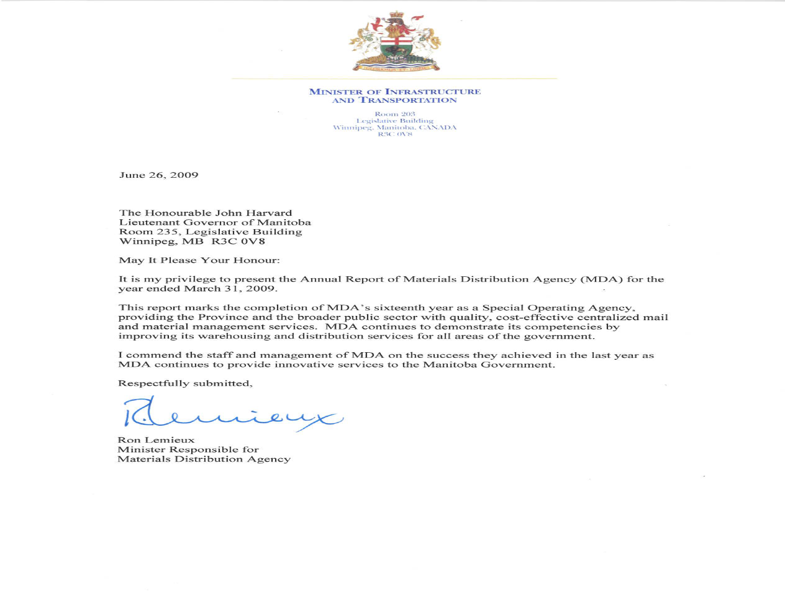

DEPUTY MINISTER’S LETTER OF TRANSMITTAL

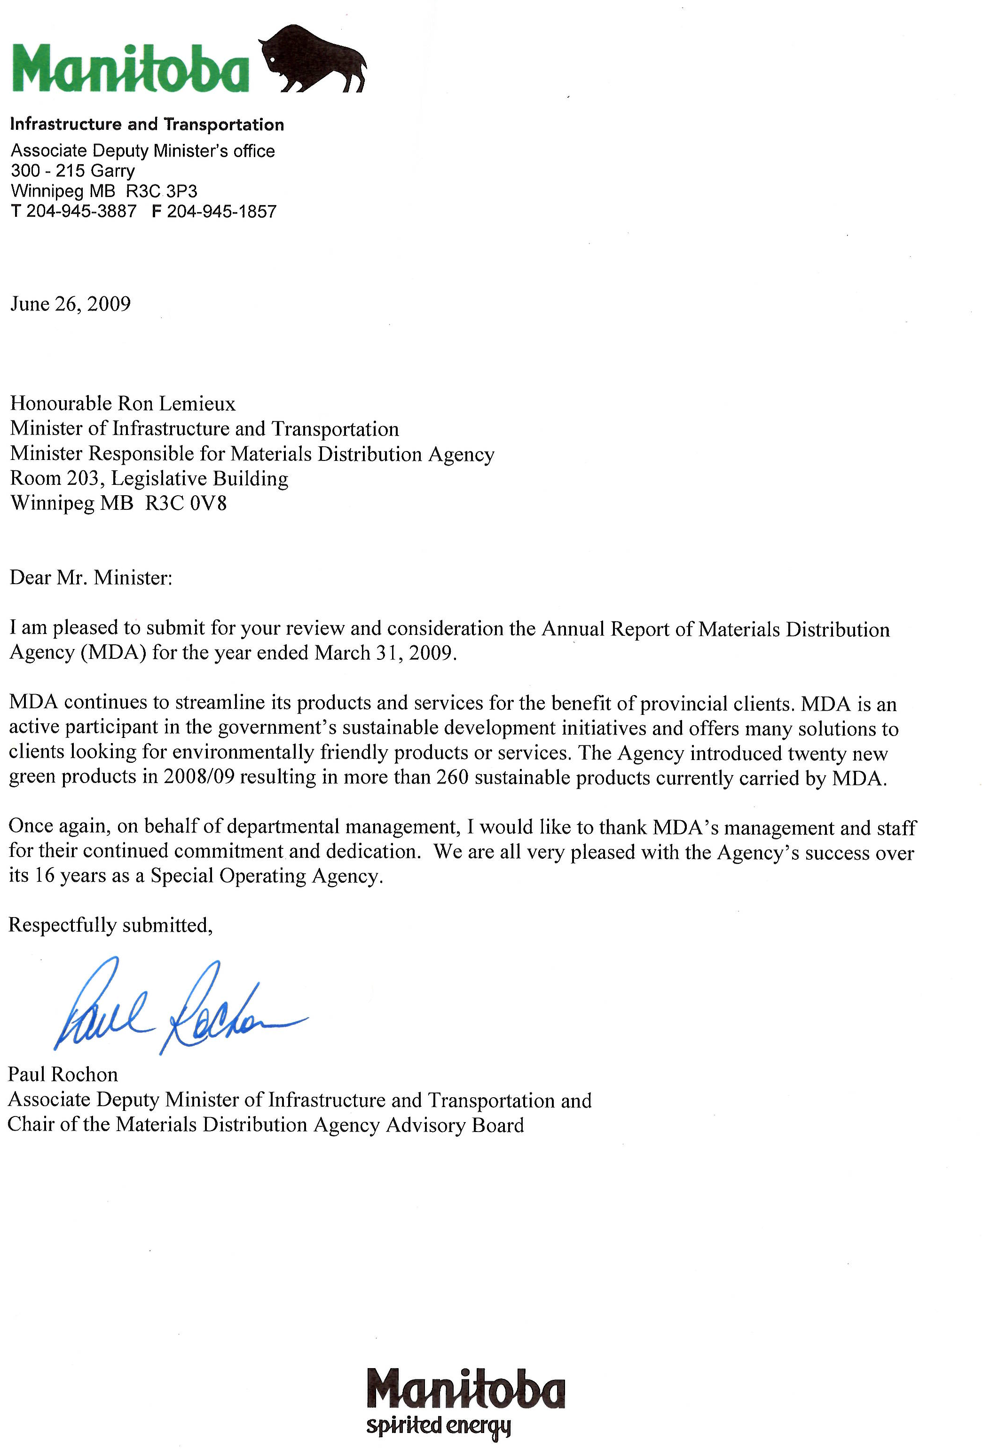

CHIEF OPERATING OFFICER’S LETTER OF TRANSMITTAL

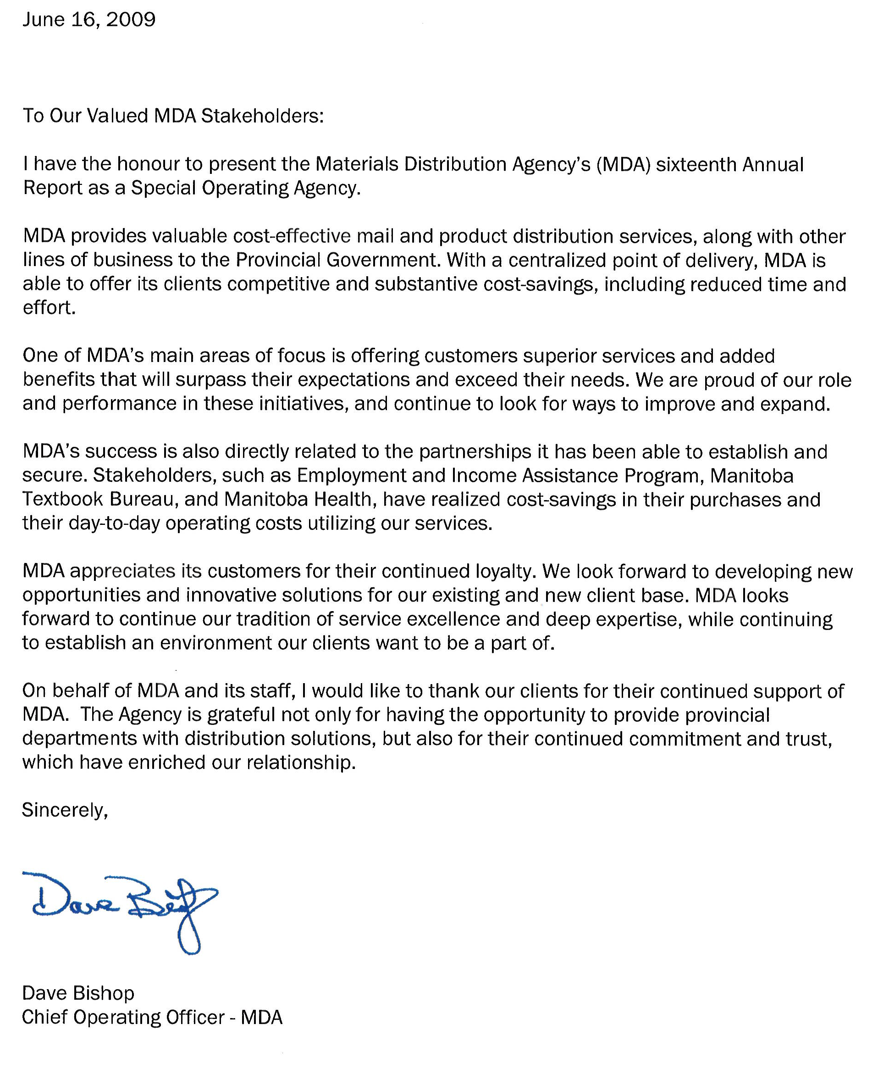

BACKGROUND

The Government of Manitoba has 17 Special Operating Agencies (SOA’s) under The Special Operating Agencies Financing Authority Act. In Manitoba, SOA’s are an operational organization within a government department. The Charter and the Schedule of Delegated Authorities define the Agency’s accountability relationships. These framework documents lay out target commitments for service levels and financial performance.

The SOA concept reflects government’s desire to support improved service to clients; increased latitude for innovation; empowerment of staff; better management of people; and clearly defined accountability for results. Agencies have more direct responsibility for results and additional flexibility regarding staffing, capital investments, rate setting, financial systems and accounting procedures.

Every year, SOA’s must prepare a business plan that provides a blueprint for the activities, revenues and expenditures for the upcoming year. Once approved, the Agency provides quarterly and yearly reports on progress against those goals.

Materials Distribution was created in 1974 to provide the government with centralized materials management for government departments, boards, commissions and agencies and became a Special Operating Agency in 1993. Postal Services was created in 1954 to provide government-wide postal services and became an SOA in 1996. The organizations amalgamated April 1, 2005. The Agency’s mandate is to cost-effectively meet the mail and material distribution requirements of organizations within the broader public service.

STRUCTURE FOR OPERATIONS

Accountability Structure

As an organization within Manitoba Infrastructure and Transportation, MDA reports directly to the Assistant Deputy Minister, Supply and Services, and is held accountable to the Associate Deputy Minister, Deputy Minister, and Minister of Infrastructure and Transportation for operational and financial performance.

The Agency operates outside of the Consolidated Fund under the Special Operating Agencies Financing Authority (SOAFA), which holds title to the Agency’s assets, provides financing for operations, and is responsible for its liabilities. Governance and accountability are substantiated by MDA’s compliance with its Operating Charter, Transfer Agreement, Management Agreement, applicable General Manual of Administration policies, and by The Special Operating Agencies Financing Authority Act. Financial and operational information and requirements are disseminated to and from Treasury Board through an SOA Coordinator at Treasury Board Secretariat.

The Accountability Structure Chart presented below outlines the current structure:

Legislative Assembly
Materials Distribution
Agency
Accountability Structure Chart
March 31, 2009

Cabinet

Minister of Infrastructure and Transportation

Treasury Board

Deputy Minister of Infrastructure and Transportation

Minister of Finance

Associate Deputy Minister of Infrastructure and Transportation

Special Operating Agencies Financing Authority

Advisory Board
Assistant Deputy Minister Supply and Services

Chief Operating Officer
Materials Distribution Agency

Advisory Board

The Advisory Board for Materials Distribution Agency meets as required to review the Agency’s financial and operating reports, the draft Business Plan, and any proposed changes to the Agency’s Charter. The Board’s members offer advice and direction on reporting and management issues of concern, and on short and long term strategic planning.

Members of the MDA Advisory Board as of March 31, 2008, are listed below.

Members of the Advisory Board for Materials Distribution Agency

CHAIR Paul Rochon
Associate Deputy Minister
Manitoba Infrastructure and Transportation

MEMBERS

Private Sector Position vacant
Representative

Client Fred Meier Kim Sharman
Representatives Assistant Deputy Minister Assistant Deputy Minister
Manitoba Conservation Manitoba Health and Healthy Living

Ex Officio Tracey Danowski David Bishop
Assistant Deputy Minister Chief Operating Officer Supply and Services Division Materials Distribution Agency
Manitoba Infrastructure and Transportation

Staff Representative Robert Nicholls
A/Logistics Manager
Materials Distribution Agency

MDA MISSION STATEMENT

Mission

This Agency provides mail and material management services to the public sector.

ORGANIZATIONAL GOALS

Employees – To increase employee job satisfaction and foster a respectful workplace.

Service – To sustain and improve customer service by developing infrastructure, setting standards and meeting or exceeding customer needs.

Growth – To grow business while maintaining or decreasing overall government expenditures.

ORGANIZATIONAL VALUES

The Agency supports its mission statements and goals with its operating values.

Reliability
MDA:
- Continually improves all aspects of its organization
- Provides consistent services
- Establishes and follows standards
- Does not make promises it can’t keep
- Is fair
- Demonstrates integrity

Teamwork
MDA:
- Behaves ethically
- Recognizes achievements
- Communicates
- Is positive
- Sees each call as an opportunity
- Values diversity of backgrounds and opinions
- Creates and supports a common direction and common goals
- Demonstrates the priority of team goals

Accountability
MDA:
- Meets deadlines
- Provides clients with quality assured goods
- Saves government clients money
- Strives to know its clients’ needs

AGENCY PRODUCTS

MDA bulk purchases a variety of commonly used supplies and distributes these goods in smaller quantities as needed by its clients. These distinct product lines are listed below:

Commodities | Line Items
Stationery and Office Supplies | 1,251
Janitorial Supplies | 371
Medical Supplies | 1,120
Home Care Equipment | 374
Office Furnishings and Furniture | 103
Brochures | 32
Total Line Items | 3,251

AGENCY SERVICES

MDA provides the following lines of business and key services:

Mail Processing
MDA processes different types of mail for clients. Staff weigh and ascertain postage of standard and oversized mail through high-speed mail machines. Employees affix appropriate postage to letter mail that exceeds the maximum dimensions or weight through two computerized shipping systems. High volume mail is processed through permit mail using pre-printed indicia on envelopes and prepaid mailings through use of numerically controlled Canada Post envelopes. The current cost to clients is made up of actual postage and a separate processing fee which varies depending on type (e.g. metered, permit, etc.). MDA has additional products, such as variable rate services, including Business Reply Mail, Returned Mail, and Short Paid Mail.

Mail Finishing
MDA provides clients with various types of Mail Finishing Services, such as envelope addressing, bursting of printed forms and cheques, folding of printed material, inserting into envelopes and manual collating of items into kits or envelopes.

Interdepartmental Mail
Clients purchase Prepaid Labels in four denominations (Letter, Oversize Letter, Small Packet, and Parcel). MDA also offers Signature Service, which provides clients with confirmation of delivery of mail.

Contract Administration
MDA offers the broader public sector access to its volume-based contracted courier and parcel rates.

Digital Printing
MDA’s Variable Data Print Service provides clients with “just-in-time” printing of electronic documents on high-speed digital black and white printers that can be immediately transferred to the Finishing, Processing, and Interdepartmental lines of business.

Home Care Equipment Rental
MDA provides a comprehensive Rental, Repair and Service Program. The Agency receives and repairs any damaged or non-functioning component and disinfects the item before returning it to the active equipment rental pool. MDA also carries out periodic safety checks on equipment in the field to ensure it is in good working condition. This program continues to grow, which is consistent with the demographics and growing reliance on Home Care solutions. MDA expects to see significant growth in the Employment and Income Assistance Program (EIA). As well, MDA is tracking EIA and Child Special Services Program equipment use. EIA has asked MDA to implement an electronic solution for tracking of equipment.

Office Equipment Service and Rental
Desktop computers have reduced the need for the Office Equipment Service Program and rental. Revenue for this line is gradually diminishing. MDA will provide this service until market demand significantly declines.

Key Copy Centres
MDA administers the Copy Centre Program. It includes ordering supplies for each copy centre, and arranging for repairs and maintenance. MDA applies a per copy charge based on user volumes recorded by electronic or manual keys. As contracts are renewed or mature, Procurement Services Branch (PSB) assesses the appropriateness of copy centre services and may replace manual keys with electronic keys. MDA is aware of the provincial strategy for integrating multi-use fax printers. This will eliminate most of the copy centres. MDA anticipates that the copy centres will be eliminated by September 30, 2009.

Warehouse and Distribution Services
MDA provides Warehouse and Distribution Services to other agencies and departments, which includes picking and packing for provincial, national and international distribution.

Transportation, Storage and Disposal Services
MDA provides moving services resulting in significant cost savings for which it consistently receives positive client feedback. Secure storage facilities are also provided. MDA also disposes of goods and furnishings government offices no longer need. Often MDA reassigns these items to other agencies that have short-term needs. MDA disposes of non-recyclable items through auction, tendered and un-tendered sales, and through recycling companies.

MARKET SEGMENT INFORMATION

Total Revenue 2008/09: $25,225,000

WAREHOUSE PRODUCTS – DISTRIBUTION INFORMATION

Number of Orders | 2008/09 | 2007/08 | 2006/07
MDA Orders | 60,148 | 55,585 | 51,045
Manitoba Textbook Bureau Orders | 12,410 | 12,584 | 15,892

Distribution of Products | 2008/09 | 2007/08 | 2006/07
Winnipeg | 61% | 60% | 54%
Rural | 39% | 40% | 46%

Delivery of Winnipeg Orders | 2008/09 | 2007/08 | 2006/07
Regular (2 days) | 95% | 91% | 93%
Same day | 1% | 3% | 4%
Pickup | 4% | 6% | 3%

2008/09 PROJECTS AND ACTIVITY STATUS HIGHLIGHTS

- Human Resources Overview

Enhance understanding of Diversity, improve staff attendance and to improve staff health by introducing staff well-being strategies
Update on strategies
- To implement a voluntary smoking cessation strategy by June 1, 2008 | - A smoking cessation program was offered in 2008/09 and one staff person entered and completed the program
- To continue the voluntary light exercise program introduced September 1, 2006 | - Staff participation in the voluntary light exercise program was excellent
- To have at least two speakers address staff on health issues each year | - Three speakers addressed MDA staff in 2008/09. They gave information on back safety, benefits of massage therapy and nutrition
- To host a Wellness Fair in the first quarter of 2008/09 | - MDA’s third annual Wellness Fair was held in May 2008
- To work with HR on developing a formal attendance program for MDA by the end of fiscal 2008/09 | - MDA’s attendance management program was started in 2008/09 and will be completed in 2009/10

Increase staff access to information, and increase internal communication between and within areas at MDA
Update on strategies
- To incorporate a staff information screen on its website by October 1, 2008 | - The website is updated with information for staff
- Complete an employee survey in the third quarter each year. Management will review the results, develop plans to make improvements, communicate to staff for feedback and implement strategies for the next business plan. | - Employee survey was completed. A communication letter was posted with results and what strategies were implemented
- Develop a Standard Operating Procedure for a formal performance appraisal system with tracking mechanism for all staff at MDA in second quarter of fiscal 2008/09. This will be done in conjunction with Human Resources | - Performance training was completed for all managers and supervisors. Formal appraisals will start in 2009/10

- Marketing and Communications Overview

Heighten exposure of MDA’s services and increase the array of services (programs) offered by MDA to departmental customers
Update on strategies
- Showcase a service offered by MDA in each of the monthly MDA flyers | - All monthly flyers showcased an MDA service
- Present MDA’s services to a minimum of four departmental executive management committees by March 31, 2009 | - The Marketing and Communications Group (MCG) Manager and the COO met in the fourth quarter and developed a strategy for 2009/10
- Continue creating advertisements to be included in Agency orders with at least one advertisement per quarter in 2008/09 | - “To Be Discontinued” (TBD) medical products were advertised in the fourth quarter

Increase exposure of MDA’s Products and Services to broader public sector markets’ and more aggressively pursue networking opportunities with organizations where relations exist from within the MCG and MDA
Update on strategies
- Review advertising and editorial opportunities in two publications targeting market segments; place ads, if determined to be cost-effective, by June 30, 2008 | - Placed ad in the “Municipal Leader” magazine and Vehicle and Equipment Management Agencies (VEMA) “Make’n Tracks” newsletter
- Participate in at least three trade show events by the end of the fiscal year | - A “Green” booth was set up at the Office Professional’s Symposium on May 28, 2008  - MCG attended the Facility Managers Conference on October 29, 2008 and the Association of Manitoba Municipalities Trade Show on November 24 and 25, 2008
- Identify at least six separate inter-agency networking opportunities and schedule meetings with these organizations by fiscal year end | - All MDA flyers and marketing advertisements are being distributed to VEMA’s distribution list

Demonstrate the benefits associated with the shopping basket model and compliance with government policies
Update on strategy
- Review the MDA website and edit as needed to strongly emphasize the benefits of buying from MDA by August 31, 2008 | - MCG staff reviewed the website and are researching the possibility to incorporate Azox software that can display products in real time and allow for easy searching  - Due to the length of time since the website was built, the software is now obsolete and does not make for ideal editing. Therefore, the MCG will explore rebuilding the website using MIT Administrative Services

Introduce green products where possible to support provincial green initiatives and provide an internal means for departments to meet their sustainable development objectives
Update on strategies
- With MDA’s Purchasing area, identify the top 20 green product alternatives for MDA and introduce at least ten new green products in the 2008/09 fiscal year | - Twenty new green products have been introduced to date

Continue to manage the Agency’s website, catalogues, flyers and brochures for regular distribution to existing clients
Update on strategies
- Publish and distribute MDA’s annual medical and janitorial/stationery catalogues in 2008/09 | - Medical catalogue distributed in the first quarter  - MDA’s janitorial/stationery catalogue distributed in the second quarter
- Publish and distribute the Agency’s monthly and quarterly flyers throughout 2008/09 | - All monthly and quarterly flyers were distributed
- Update and distribute advertising kit for MDA “Products and Services Catalogue” by January 31, 2009 | - Brochure has been created. Additional materials (Mail Service brochure and fact sheet) need to be created to complete the package
- Continue to produce at least four MDA related advertisements to be inserted into shipments throughout 2008/09 | - Medical product TBD flyers are currently being distributed in outgoing janitorial/stationery orders
- Coordinate website launch event by June 30, 2008 | - Website launch is being planned for fiscal year 2009/10
- Coordinate product promotion events in at least four government locations with high client traffic by March 31, 2009 | - Product displays were set up in nine government buildings throughout August and September
Obtain client feedback to be used to address short-comings, procedures, and market MDA’s products/services in a manner to achieve the highest return for efforts made and dollars spent
Update on strategies
- Perform first of annual client group surveys and take necessary actions in 2008/09 to align findings with MDA’s strategies | - Survey was performed to measure client’s perspective on “Buying Green”
- Work with Mail Service area to perform a review of mail and its various services to assess opportunities in 2008/09 | - Strategy was developed and a review is underway with results scheduled for the second quarter of the 2009/10 fiscal year

Provide Treasury Board with a comprehensive strategy to address greater use of MDA’s services, plans for marketing MDA’s services, plans to ensure the Agency remains competitive in the future, and opportunities to enhance existing services to sustain long-term profitability
Update on strategy
- Submit a response to Treasury Board by July 31, 2008 | - Completed and report submitted to Treasury Board

- Client Service Overview

Perform return authorizations through an electronic system for the Client Service area
Update on strategies
- Create an electronic client issue/complaint form and use as a return authorization process by September 31, 2008 | - This is part of the IT plan. Project started in the fourth quarter
- Write a return authorization standard operating procedure by March 31, 2009 | - SOP is under development and scheduled for review by COO in early 2009/10

Review standard operating procedures (SOPs) for medical equipment that fall within the maintenance and repair program
Update on strategies
- Review existing processes and assess how many of the SOPs require updates by end of the second quarter | - All SOPs have been updated by the end of the fourth quarter
- Modify SOPs based on manufacturer recommendations and specifications by the end of the third quarter | - SOPs were completed in the second quarter. Manufacturer specifications have been incorporated into 21 user manual pamphlets for the public sector

Review MDA policies and procedures for infectious control measures for the medical staff working in public sector homes
Update on strategies
- Re-examine surface disinfecting products by the first quarter | - Completed and new products being ordered
- Develop policies and SOPs for warehouse staff handling soiled medical equipment by the end of the second quarter | - SOP completed on personal protective equipment in the second quarter  - Policies and standards were completed in the fourth quarter
- Create policies and procedures for technicians servicing equipment in public sector homes by March 30, 2009 | - In process with several draft policies and procedures completed to date  - Final policies and procedures to be completed in the 2009/10 first quarter

As of July 2007, Client Service Representatives (CSRs) are dealing with a higher volume of problematic clients picking up medical supplies
Update on strategies
- Review options and costs for the restructure of the front counter by the end of the 2008/09 first quarter | - MDA met with staff from Accommodation Services Division (ASD) and are waiting for blueprints
- Start construction by the end of the 2008/09 third quarter | - ASD is estimating construction will begin in the 2009/10 fiscal year
- Provide CSRs with training courses to deal with difficult clients before the end of fiscal year 2008/09 | - Training will be completed by March 31, 2009. All CSRs are enrolled in customer service courses

This area of the equipment program has been steadily growing. MDA needs to track staff workloads within the Home Care/Employee and Income Assistance (EIA) recycled equipment programs along with the in-house cleaning of products. MDA can then allocate current staff and recommend if additional staff are required
Update on strategies
- Track increases in hospital bed deliveries/pickups, including same day rushes within Winnipeg and Regional Health Authorities (RHAs) by September 30, 2008 | - Completed
- Track hours spent on cleaning and repairing Home Care and EIA medical equipment by September 30, 2008 | - Completed
- Establish service requirements on new medical equipment by September 30, 2008 | - Completed and MDA will establish updated service requirements as new equipment is introduced
- Make recommendations on staffing levels by December 31, 2008 | - Completed with term position proposed for January 2009

Rural Home Care managers request that MDA meet their equipment requests for Bariatric clients within their regions
Update on strategies
- Discuss Bariatric requirements with RHA directors by the end of second quarter | - Completed - MDA is working with the RHAs to introduce new equipment to the Home Care Program. MDA will communicate with the Provincial Home Care Mangers Network
- Review new equipment for rental and purchase by the end of the 2008/09 third quarter | - Review has started and will be ongoing until direction is received from the Provincial Home Care Managers Network Committee and the WRHA Press Committee
- Establish rental rates and service requirements on new Bariatric equipment by the end of the 2008/09 fiscal year | - Rates and service requirements are developed for this equipment

Review statistical data to provide management with a benchmark on the effectiveness of the Client Service area
Update on strategy
- Implement and track two or three Key Performance Indicators (KPIs) by the end of the 2008/09 second quarter | - Completed – KPIs have been implemented and are being tracked for statistical analysis once historical data is generated

- Contracts and Purchasing Overview

Establish and manage contracts to best meet the needs of the Agency and its clients
Update on strategies
- Meet with Procurement Services Branch (PSB) monthly to discuss tender and contractual issues | - Contracts and Purchasing Manager met with PSB monthly in the fourth quarter
- Develop new specifications for the furniture contract by June 1, 2008 | - Project deferred at the request of PSB to establish new government specifications

Reduce the number of backorders and their associated cost for the Agency
Update on strategies
- Monitor backorders and maintain a line item industry standard of 1.5% or less for all medical, stationery and janitorial items | - Backorders were at 1.7% for the fourth quarter. The annual average was 1.6%
- Adjust order point quantities to meet client demands and vendor shipment schedules | - Adjusted on a regular basis and at the start of a new contract
- Provide backorder report quarterly | - Provided to COO

Reduce the number of items sold individually by December 31, 2008
Update on strategies
- Review all sales items sold individually and develop a list of those items where it would be more practical if sold in larger quantities | - Review completed and 50 items will be sold in larger quantities
- Inform clients of U of M changes | - All clients were informed of U of M changes by the MCG in the fourth quarter

Review aging inventory and discontinue items as necessary
Update on strategy
- Create an aging inventory SOP by June 30, 2008 | - SOP completed and implemented

Standardize product descriptions within MDA’s internal electronic systems to improve data search mechanisms for internal and external clients
Update on strategies
- Develop a committee to review current item description formats and decide upon a standard format | - Completed with a standard format decided upon and presented to MDA’s COO for final approval
- Develop an SOP to reflect the format | - SOP completed and implemented
- Review each item description and change to the standard format where required by March 31, 2009 | - Completed

Review statistical data to provide management with a benchmark on the effectiveness of the Contracts and Purchasing area
Update on strategy
- Implement and track two or three KPIs by the end of the 2008/09 second quarter | - Completed – KPIs have been implemented and are being tracked for statistical analysis

- Logistics Overview

Enhance workflow, maximize productivity and increase accuracy while sourcing hidden costs to control expenditures
Update on strategies
- Analyze the inventory control area and make recommendations by September 30, 2008 | - Completed – Recommendations were given to MDA’s COO in the second quarter
- Evaluate the recommendations and decide if inventory control needs to be expanded based on financial savings and quality improvements by October 31, 2008 | - Study has been delayed to the second quarter of 2009/10 due to staffing shortages

Provide training on leadership to enhance management potential of employees by offering specific procedure, safety, health and wellness training tools to all staff
Update on strategies
- Hold a minimum of 10 supervisor meetings in 2008/09 and offer continued training of team leads by incorporating training topics into each meeting | - Supervisor meetings are ongoing and three meetings were held in the fourth quarter
- Develop training plans for each supervisor and team lead by the end of the 2008/09 second quarter | - All team leads are enrolled in the five course “Essentials of Supervision Program” through Organizational and Staff Development (OSD)
- Continue to develop and implement Workplace Health and Safety planning | - Literature on safety handed out monthly
- Have a minimum of six warehouse area meetings in 2008/09 | - All warehouse areas meet monthly
- Analyze security levels for the entire facility and make recommendations to MDA’s COO by June 30, 2008 | - Completed - Rear pedestrian doors are being equipped with two-way communication devices and equipment area front entry door received a new locking device

Develop and implement statistical tracking tools to capture volume tracking and delivery turn around times
Update on strategies
- Develop daily volume tracking of all shipments through the Logistics area by June 30, 2008 | - Statistics are being compiled and processes are in the developmental stage
- Develop and report on feasibility of delivery turn around time statistics by end of third quarter | - MDA’s IT area is determining if electronic tracking is possible

Analyze mail function procedures and overall processes
Update on strategies
- Determine feasibility of Mail Service satellite operations by June 30, 2008 | - 405 Broadway satellite review is complete. This satellite was closed on October 01, 2008 and process is working well. Rural area satellite offices are being analyzed and will be reviewed in the 2009/10 first quarter
- Develop a replacement plan for old equipment to be presented to Finance Manager and COO by June 30, 2008 | - Completed with a new optical mark reader inserter received in the third quarter

Review statistical data to provide management with a benchmark on the effectiveness of the Logistics area
Update on strategy
- Implement and track two or three KPIs by the end of the 2008/09 second quarter | - Completed – KPIs have been implemented and are being tracked for statistical analysis

- Finance and Technology Overview

Review the Mail Service Billing System (Hermes) and customer issue electronic tracking
Update on strategies
- Review the mail finishing billing process and determine integration into MDA’s Great Plains system by June 30, 2008 | - First phase completed. Mail jobs are being entered into Great Plains by mail finishing staff  - The second phase is underway and will be completed in the first quarter of 2009/10
- Work with Client Service and Logistics areas to study the feasibility of creating an electronic client issue tracking system by June 30, 2008 | - Feasibility study completed and project was approved by COO. Development of the tracking system was started in the fourth quarter

Finance area will develop review mechanisms to analyze all lines of business within MDA annually
Update on strategies
- Develop an SOP for assessing each line of business on an annual basis with timelines and reporting mechanisms by the end of fiscal year 2008/09 | - MDA hired a Business Line Analyst with a start date in early January 2009
- Review all Mail Service satellite operations with the MCG and Finance Manager to determine feasibility by June 30, 2008 | - 405 Broadway satellite review complete and was closed on October 01, 2008. Rural area satellite offices are under review

Review statistical data to provide management with a benchmark on the effectiveness of the Finance/IT area
Update on strategy
- Implement and track two or three KPIs by the end of the 2008/09 second quarter | - Completed – KPIs have been implemented and are being tracked for statistical analysis once historical data is generated

Wellness Update

MDA’s goal is to become a healthy workplace, thus aligning with the province’s priority to promote healthy living. MDA recognizes the substantial savings to the Agency and health care system in the future that can be realized when people remain healthy longer. In addition, productivity increases with healthier workers.

MDA is constantly looking for ways to make the workplace better and to become a workplace of choice for future civil servants.

The MDA Wellness Coordinator is a member of the Provincial Workplace Wellness Alliance. It promotes networking with other organizations who also view employee wellness as critical to the success of their organizations.

The Wellness Committee is composed of enthusiastic volunteers who want to make a difference. In 2008/09, MDA:
- Held its annual wellness fair for staff and family. Experts spoke on various health-related topics, such as reducing workplace stress, back safety, and nutrition. MDA also ran a fitness boot camp as part of the fair
- Held a winter Dance Dance Revolution challenge
- Hosted two successful healthy lunches for staff
- Created a wellness board in the lunch room displaying various health information and resources which are updated monthly

FINANCIAL OVERVIEW

Review of Operations
MDA has seen the volume and breadth of products grow in most commodity lines. Current clients are ordering more commonly stocked products, while also requesting that MDA expand its lines of goods. As needs change, clients look to MDA to assume warehousing and distribution at lower costs.

The following financial review and analysis compares the actual results for the year ended March 31, 2009 to the projections for the same period, and to the actual results for the year ended March 31, 2008.

MDA reported a net income of $172,000, compared to a projected net income of $27,000 for the year ended March 31, 2009 and a net income of $83,000 for the year ended March 31, 2008.

 | 2009  Actual | 2009  Projected | 2009 Actual vs. Projected | 2008  Actual | 2009 Actual  vs.  2008 Actual
Warehouse Sales  Cost of goods sold | 14,331  11,408 | 11,206  8,960 | 3,125  2,448 | 12,490  9,961 | 1,841  1,447
Gross profit | 2,923 | 2,246 | 677 | 2,529 | 394
Service Revenue  Total Revenue  Expenses  Salaries & benefits  Occupancy costs  Administrative | 10,894  13,817  4,112  835  8,698 | 9,565  11,811  4,107  851  6,826 | 1,329  2,006  5  (16)  1,872 | 10,416  12,945  4,186  724  7,952 | 478  872  (74)  111  750
Total Expenses | 13,645 | 11,784 | 1,861 | 12,862 | 783
Net income/(loss) | 172 | 27 | 145 | 83 | 89
Retained Earnings | 4,137 | 4,125 | 12 | 3,968 | 169
Revenue Sharing | - | - | - | 400 | (400)

Financial Position
The Agency did not use its working capital payable line of credit at any time during this fiscal year and has no working capital payable outstanding.

Remaining cash generated by operations was used to purchase capital and other.

Ratio Analysis

Ratio | 2009 | 2008 | 2007 | 2006
Return on total revenue | .68% | .64% | -.79% | − .002 %
Return on average assets | 2.33% | 1.08% | -2.21% | .003%
Gross profit percentage | 20.4% | 20.40% | 19.35% | 19.00%
Debt to equity | .42 to 1 | .48 to 1 | .44 to 1 | .39 to 1
Current ratio | 1.74 to 1 | 1.62 to 1 | 1.74 to 1 | 1.81 to 1
Days sales in receivables | 39 days | 46 days | 49 days | 48 days
Inventory turnover | 8.23 times | 6.63 times | 6.54 times | 6.16 times

Performance Measures

Turn Around Time (MDA): | 2009 | 2008 | 2007 | 2006
Health Orders – Urban  Health Orders – Rural  Other Goods – Urban  Other Goods – Rural  MB Textbook Bureau | 1  1  1  1  1 | 1  2  1  2  2 | 1  2  2  2  3 | 1  2  1  2  3
No. Sales Invoices | 64,506 | 56,557 | 53,643 | 62,216
No. Inventory Items | 3,251 | 2,563 | 4,123 | 4,149

APPENDIX A – MDA AUDITED FINANCIAL STATEMENTS

MATERIALS DISTRIBUTION AGENCY

FINANCIAL STATEMENTS

MARCH 31, 2009
AUDITORS' REPORT
To the Special Operating Agencies Financing Authority

We have audited the balance sheet of the Materials Distribution Agency, an Agency of the Special Operating Agencies Financing Authority, Province of Manitoba as at March 31, 2009 and the statements of income, comprehensive income and retained earnings and cash flow for the year then ended. These financial statements are the responsibility of the Agency's management. Our responsibility is to express an opinion on these financial statements based on our audit.
We conducted our audit in accordance with Canadian generally accepted auditing standards. Those standards require that we plan and perform an audit to obtain reasonable assurance whether the financial statements are free of material misstatement. An audit includes examining, on a test basis, evidence supporting the amounts and disclosures in the financial statements. An audit also includes assessing the accounting principles used and significant estimates made by management, as well as evaluating the overall financial statement presentation.
In our opinion, these financial statements present fairly, in all material respects, the financial position of the Agency as at March 31, 2009 and the results of its operations and cash flow for the year then ended in accordance with Canadian generally accepted accounting principles.
The financial statements as at March 31, 2008 and for the year then ended were audited by other auditors, who expressed an opinion without reservation on those financial statements in their report dated April 30, 2008.

May 6, 2009 CHARTERED ACCOUNTANTS
BALANCE SHEET
(in thousands)
MARCH 31, 2009 2009 2008
ASSETS
CURRENT ASSETS
Cash and short term deposits $ 910 $ 732
Accounts receivable 2,424 2,989
Receivable - Province of Manitoba (Note 5) - 412
Inventories (Note 6) 1,284 1,485
Prepaid expenses 179 171
4,797 5,789
LONG TERM INVESTMENTS (Note 7) 412 -
CAPITAL ASSETS (Note 8) 1,764 1,641
OTHER ASSETS (Note 9) 153 238
$ 7,126 $ 7,668
LIABILITIES
CURRENT LIABILITY
Accounts payable and accrued liabilities $ 2,565 $ 3,321
SEVERANCE LIABILITY (Note 10) 425 379
2,990 3,700
EQUITY
CONTRIBUTED EQUITY (Note 12) 1,297 1,297
RETAINED EARNINGS 2,839 2,671
4,136 3,968
Commitments (Note 13)
$ 7,126 $ 7,668
STATEMENT OF INCOME AND COMPREHENSIVE INCOME AND RETAINED EARNINGS
(in thousands)
FOR THE YEAR ENDED MARCH 31, 2009 2009 2008
WAREHOUSE SALES (Schedule 1) $ 14,327 $ 12,517
COST OF SALES 11,408 9,961
GROSS PROFIT 2,919 2,556
SERVICE REVENUE (Schedule 1) 10,897 10,389
NET INCOME BEFORE THE FOLLOWING 13,816 12,945
EXPENSES
Salaries and benefits 4,112 4,186
Occupancy costs 835 724
Administrative expenses (Schedule 2) 8,701 7,952
13,648 12,862
NET INCOME AND COMPREHENSIVE INCOME FOR THE YEAR 168 83
RETAINED EARNINGS, beginning of year 2,671 2,988
2,839 3,071
REVENUE SHARE - PROVINCE OF MANITOBA - (400)
RETAINED EARNINGS, end of year $ 2,839 $ 2,671

STATEMENT OF CASH FLOW
(in thousands)
FOR THE YEAR ENDED MARCH 31, 2009 2009 2008
CASH FLOW FROM (USED IN)
OPERATING ACTIVITIES
Net income and comprehensive income for the year $ 168 $ 83
Adjustment for
Amortization 979 940
1,147 1,023
Changes in the following
Accounts receivable 564 (120)
Inventories 202 36
Prepaid expenses (9) 46
Accounts payable and accrued liabilities (757) 264
Severance liability 46 (4)
1,193 1,245
FINANCING ACTIVITY
Revenue sharing - Province of Manitoba - (400)
INVESTING ACTIVITIES
Capital asset additions (1,015) (836)
Change in receivable - Province of Manitoba 412 -
Change in long term investments (412) -
(1,015) (836)
CHANGE IN CASH AND SHORT TERM DEPOSITS 178 9
CASH AND SHORT TERM DEPOSITS, beginning of year 732 723
CASH AND SHORT TERM DEPOSITS, end of year $ 910 $ 732
1. NATURE OF ORGANIZATION
The Government of Manitoba established a central warehouse operation in 1974. Its mandate is to effectively meet the cost needs of departments and certain boards, commissions and agencies of the Crown, for a variety of commonly used items.
Effective April 1, 1993, Materials Distribution Agency (the "Agency") was designated as a Special Operating Agency pursuant to The Special Operating Agencies Financing Authority Act, Cap. S185, C.C.S.M. and operates under a charter approved by the Lieutenant Governor in Council.
In 1956 Mail Management (Postal Service) was created as a branch of the Manitoba Provincial Government to provide centralized postal management. Effective April 1, 1996 the Postage Service was renamed Mail Management Agency and designated as a Special Operating Agency ("SOA") pursuant to The Special Operating Agencies Financing Authority Act, Cap. S185, C.C.S.M. and operates under a charter approved by the Lieutenant Governor in Council.
Effective April 1, 2005 the operations of the Materials Distribution Agency and the Mail Management Agency were amalgamated. The amalgamated operations have been operating as the Materials Distribution Agency.
The Agency is financed through the Special Operating Agencies Financing Authority (SOAFA). The Financing Authority has the mandate to hold and acquire assets required for and resulting from the Agency's operations. It finances the Agency through repayable loans and working capital advances. This financial framework enables the Agency to operate in a business like manner according to public policy expectations.
A Management Agreement between the Financing Authority and the Minister of Transportation and Government Services assigns responsibility to the Agency to manage and account for Agency-related assets and operations on behalf of the Financing Authority.
The Agency continues to be part of Manitoba Transportation and Government Services under the general direction of the Assistant Deputy Minister, Supply and Services Division, and ultimately the policy direction of the Deputy Minister and Minister.
The Agency remains bound by relevant legislation and regulations. It is also bound by administrative policy except where specific exemptions have been provided in its charter in order to meet business objectives.
The Agency is economically dependent on the Province of Manitoba and the Manitoba Regional Health Authorities deriving most of its revenue and all of its capital financing requirements from the Province. These transactions are recorded at the exchange amount, which is the amount agreed upon by both parties.

2. CHANGE IN ACCOUNTING POLICIES
Effective April 1, 2008, the Agency adopted the following new handbook sections issued by the Canadian Institute of Chartered Accountants (CICA):
Section 1535 Capital Disclosures
Section 1535 establishes standards for disclosing information about an entity's capital and how it is managed. These standards require an entity to disclose its objectives, policies and processes for managing capital, a summary of quantitative data about what it manages as capital and whether it complied with any externally imposed capital requirements to which it is subject and, if not, the consequences of such non-compliance. (See disclosure in Note 3)
Section 3862 Financial Instruments - Disclosures
Section 3862 modifies the disclosure requirements for financial instruments that were included in Section 3861, Financial Instruments – Disclosure and Presentation. The new standards require an entity to provide disclosures in its financial statements that enable users to evaluate the significance of financial instruments on its financial position and performance, the nature and extent of the risks to which it is exposed during the period and at the balance sheet date, and how those risks are managed. (See disclosure in Note 15)
Section 3863 Financial Instruments - Presentation
Section 3863 carries forward the presentation requirements of Section 3861, Financial Instruments – Disclosure and Presentation, unchanged.
The above noted new standards have no impact on the recognition, measurement or presentation of financial instruments in the Agency’s year end financial statements.
Section 3031 Inventories
Section 3031 Inventories replaces Section 3030 Inventories. It provides more guidance on the measurement and disclosure requirements for inventories. The adoption of Section 3031 did not have an impact on the recognition, measurement or presentation of inventory in the Agency’s year end financial statements.
3. SUMMARY OF SIGNIFICANT ACCOUNTING POLICIES
Basis of Reporting
The financial statements have been prepared in accordance with Canadian generally accepted accounting principles (GAAP).
Inventory
Inventory is valued at the lower of cost and net realizable value with the cost being determined on a first-in, first-out basis.
Included in cost of sales is $11,386 (2008 - $9,889) of inventory recognized as an expense during the year.

3. SUMMARY OF SIGNIFICANT ACCOUNTING POLICIES (continued)
Capital Assets
Capital assets are recorded at cost and amortized over their estimated useful lives as follows:
Computer equipment 20% straight line
Fixtures 20% straight line
Leasehold improvements 5 years straight line
Office equipment 20% straight line
Production equipment 20% Declining balance
Rental equipment 2 - 5 years straight line
Warehouse equipment 20% Declining balance
Other Assets
Other assets are recorded at cost and amortized as follows:
Computer conversion 5 years straight line
Relocation expenses 10 years straight line

Revenue Recognition
Warehouse sales are recognized when the products are shipped. Service revenues are recognized based on the provision of services provided.
Capital disclosures
The Agency’s capital management policy is to maintain sufficient capital to meet its objectives through its retained earnings by managing transfers of surplus funds to the Province of Manitoba; meet short-term capital needs with working capital advances from the Province of Manitoba; and meet long-term capital needs through long-term debt with the Province of Manitoba. There were no changes in the Agency’s approach to capital management during the period. The Agency's capital consists of contributed equity and retained earnings.
The Agency is not subject to externally imposed capital requirements.
Use of Estimates
The preparation of financial statements in conformity with generally accepted accounting principles requires management to make estimates and assumptions that affect the reported amounts of assets and liabilities and disclosure of contingent assets and liabilities at the date of the financial statements and the reported amounts of revenues and expenses during the reporting period. Actual results could differ from these estimates.

3. SUMMARY OF SIGNIFICANT ACCOUNTING POLICIES (continued)
Financial Instruments - recognition and measurement
Financial assets and liabilities are initially recorded at fair value. Measurement in subsequent periods depends on the financial instrument’s classification. Financial instruments are classified into one of the following five categories: held for trading; available for sale; held to maturity; loans and receivables; and other financial liabilities. All financial instruments classified as held for trading or available for sale are subsequently measured at fair value with any change in fair value recorded in net earnings and other comprehensive income, respectively. All other financial instruments are subsequently measured at amortized cost.
The Agency has designated its financial instruments as follows:
Cash and short term deposits and long term investments are classified as financial assets held for trading and are measured at fair value with gains and losses recognized in net earnings. Due to the relatively short period to maturity of these financial assets, the carrying values approximate their fair values.
Accounts receivable are classified as loans and receivables. These financial assets are recorded at their amortized cost using the effective interest rate method.
Accounts payable and accrued liabilities are classified as other financial liabilities. These financial liabilities are recorded at their amortized cost using the effective interest rate method.
Gains and losses on financial instruments subsequently measured at amortized cost are recognized in the statement of earnings and retained earnings in the period the gain or loss occurs. Changes in fair value on financial instruments classified as held for trading are recognized in the statement of earnings and retained earnings for the current period. Changes in fair value on financial instruments classified as available for sale would be recorded in other comprehensive income until realized, at which time they are recorded in the statement of earnings and retained earnings.
Fair value of financial instruments
The fair values of accounts receivable and accounts payable and accrued liabilities approximate their carrying values due to their short-term maturity.
4. FINANCING ARRANGEMENTS
The Special Operating Agencies Financing Authority has provided the Agency with an authorized line of working capital of $2,300 of which $nil was used at March 31, 2009.

5. RECEIVABLE FROM PROVINCE OF MANITOBA
The receivable from the Province of Manitoba was for vacation entitlements earned by the employees of the Agency prior to creation of the Special Operating Agency and severance pay benefits prior to April 1, 1998. The balance is comprised of:
2009 2008
Vacation entitlements $ - $ 116
Severance pay benefits - 296
$ - $ 412
The balance was paid by the Province of Manitoba on March 31, 2009. (See Note 7)
6. INVENTORIES
2009 2008
Medical supplies $ 607 $ 583
Equipment 30 82
Stationary 439 520
Janitorial 194 230
New furniture 14 70
$ 1,284 $ 1,485

7. LONG TERM INVESTMENTS
The Province of Manitoba accepted responsibility for the vacation entitlements earned by the employees of the Agency prior to its designation as SOA, and the severance pay benefits accumulated to March 31, 1998 for certain of the Agency's employees. Accordingly, the Agency recorded a receivable of $412 from the Province of Manitoba for these accumulated benefits. Effective March 31, 2009 the Province of Manitoba paid the receivable balances related to the funding for these liabilities and has placed the amount of $412 into a trust account bearing interest at 0.75% and maturing on March 30, 2010 to be held on the Agency's behalf until the cash is required to discharge the related liabilities. However, this is only likely to happen on the dissolution of the Agency. As such, this amount has been classified as a long term asset.
8. CAPITAL ASSETS
Accumulated Net Book Value
Cost Amortization 2009 2008
Computer equipment $ 226 $ 207 $ 19 $ 3
Fixtures 112 109 3 -
Leasehold improvements 727 710 17 25
Office equipment 64 64 - -
Production equipment 284 284 - 44
Rental equipment 7,220 5,774 1,446 1,300
Warehouse equipment 804 525 279 269
$ 9,437 $ 7,673 $ 1,764 $ 1,641
9. OTHER ASSETS
Accumulated Net Book Value
Cost Amortization 2009 2008
Computer conversion $ 337 $ 307 $ 30 $ 85
Relocation 287 164 123 153
$ 624 $ 471 $ 153 $ 238
10. SEVERANCE LIABILITY
Effective April 1, 1998, the Agency began recording accumulated severance pay benefits for its employees. The amount of severance pay obligations is based on actuarial calculations. The periodic actuarial valuations of these liabilities may determine that adjustments are needed to the actuarial calculations when actual experience is different from that expected and/or because of changes in actuarial assumptions used. The resulting actuarial gains or losses are amortized over the expected average remaining service life of the related employee group.
An actuarial report was completed for the severance pay liability as of December 31, 2005. The report provides a formula to update the liability on an annual basis. In accordance with the formula, the Agency's actuarially determined net liability for accounting purposes as at March 31, 2009 was $425 (2008 - $379). Commencing in the 2006 fiscal year the actuarial loss of $40 is being amortized over the 15 year expected average remaining service life of the employee group.

10. SEVERANCE LIABILITY (continued)
Significant long-term actuarial assumptions used in the March 31, 2005 valuation, and in the determination of the March 31, 2009 present value of the accrued severance benefit obligation were:
Annual rate of return
inflation compontent 2.50%
real rate of return 4.00%
6.50%
Assumed salary increase rates
annual productivity increase 0.75%
annual general salary increase 3.25%
4.00%
11. PENSION BENEFITS
Employees of the Agency are eligible for pension benefits in accordance with the provisions of the Civil Service Superannuation Act (CSSA), administered by the Civil Service Superannuation Board (CSSB). The CSSA established a defined benefit plan to provide benefits to employees of the Manitoba Civil Service and to participating agencies of the Government, including the Agency, through the Civil Service Superannuation Fund (CSSF).
Effective March 31, 2001, pursuant to an agreement with the Province of Manitoba, the Agency transferred to the Province the pension liability for its employees. Commencing April 1, 2001, the Agency was required to pay to the Province an amount equal to its employees’ current pension contributions.
The amount paid for 2009 was $433 (2008 - $410). Under this agreement, the Agency has no further pension liability.

12. CONTRIBUTED EQUITY
Loan Authority - April 1, 1993
The SOAFA and the Province of Manitoba entered into a Transfer Agreement respecting the transfer from Manitoba to the Financing Authority of inventories and capital assets valued at $1,464 required for the continuing operation of the Agency as at March 31, 1993. The Agency repaid the debt portion of $732 (being one-half of the value of the assets) and recorded the balance, $732, as Manitoba's contributed equity in the Financing Authority as related to the Agency operations.
Loan Authority - April 1, 1996 MMA
SOAFA and the Province of Manitoba entered into a Transfer Agreement respecting the transfer from Manitoba to the Financing Authority of equipment valued at $102 required for continuing operations of the Mail Management Agency as at March 31, 1996. The Mail Management Agency (now Materials Distribution Agency) repaid the debt portion in the amount of $51 (being one-half of the value of the assets) and recorded the balance of $51 as Manitoba's contributed equity in the Financing Authority as related to the Agency's operations.
Loan Authority - April 1, 1997
SOAFA and the Province of Manitoba entered into a Transfer Agreement respecting the transfer from Manitoba to the Financing Authority for the net assets of the Home Care Equipment and Supply Program valued at $1,027 as at April 1, 1997. The Agency repaid the debt portion of $513 (being one-half of the value of the assets) and recorded the balance of $514 as Manitoba's contributed equity in the Financing Authority as related to the Agency's operations.
13. COMMITMENTS
Leased Premises
On March 24, 2003, the Agency took partial possession of a rental property consisting of 76,067 square feet at 1715 St. James Street, Winnipeg, Manitoba. The lease is for a term of ten years with an additional five year option commencing May 1, 2003. The payments over the next five years are $521 per year.
Rental Agreement
The Agency has not entered into lease agreements with the Province of Manitoba for the four locations that it operates (405 Broadway, Winnipeg; 450 Broadway, Winnipeg; 340 - 9th Street, Brandon; and 25 Tupper Street, Portage La Prairie). As at March 31, 2009 the Agency no longer operates at 405 Broadway, Winnipeg. Occupancy charges for the year ended March 31, 2009 were $16 (2008 - $21)
14. INTEREST RECEIVED
The Agency received interest during the year of $10 (2008 - $17).

15. FINANCIAL INSTRUMENTS - RISK MANAGEMENT
In the normal course of operations the Agency is exposed to various financial risks. The financial risk management objectives and policies are as follows:
Credit risk
Credit risk is the risk that one party to a financial instrument fails to discharge an obligation and causes financial loss to another party. Financial instruments which potentially subject the Agency to credit risk consist principally of cash and short term deposits, accounts receivable and long term investments.
The maximum exposure of the Agency to credit risk at March 31, 2009 is:
Cash and short term deposits $ 910
Accounts receivable 2,424
Long term investments 412
$ 3,746
Cash and short term deposits and long term investments: The Agency is not exposed to significant credit risk as the cash and term deposits are primarily held by the Minister of Finance.
Accounts receivable: The Agency is not exposed to significant credit risk as the nature of the accounts receivable is with related entities and consists of a large client base and payment in full is typically collected when it is due. The Agency establishes an allowance for doubtful accounts that represents its estimate of potential credit losses. The allowance for doubtful accounts is based on management’s estimates and assumptions regarding current market conditions, customer analysis and historical payment trends. These factors are considered when determining whether past due accounts are allowed for or written off. The balance in the allowance for doubtful accounts at March 31, 2009 was $96 (2008 - $21)
Liquidity risk
Liquidity risk is the risk that the Agency will not be able to meet its financial obligations as they come due.
The Agency manages liquidity risk by maintaining adequate cash balances and by review from the Province of Manitoba to ensure adequate funding will be received to meet the obligations.
Market risk
Market risk is the risk that changes in market prices, such as interest rates and foreign exchange rates, will affect the Agency’s income or the fair values of its financial instruments. The significant market risk the Agency is exposed to is interest rate risk.
Interest rate risk
Interest rate risk is the risk that the fair value or future cash flows of a financial instrument will fluctuate because of changes in market interest rates. The interest rate exposure relates to short term deposits.
The interest rate risk on short term deposits is considered to be low because of their short-term nature.

16. COMPARATIVE FIGURES
Certain of the comparative figures have been reclassified to conform with the classifications used in the current year.
SCHEDULE OF WAREHOUSE SALES AND SERVICE REVENUE
(in thousands)
FOR THE YEAR ENDED MARCH 31, 2009
2009 2008
WAREHOUSE SALES
Medical supplies $ 4,835 $ 4,535
Stationery 4,079 3,629
Furniture 3,235 2,088
Janitorial 1,612 1,455
Health equipment 423 518
Special projects 143 292
$ 14,327 $ 12,517
SERVICE REVENUE
Disposal $ 5 $ 4
Manitoba Textbook Bureau 291 292
Freight 693 584
Moving 594 617
Storage 78 80
Office equipment - maintenance program 27 45
Office equipment - copy centres 419 475
Mail services 6,108 5,859
Home care equipment rentals 2,484 2,325
Other income 198 108
$ 10,897 $ 10,389
SCHEDULE OF ADMINISTRATIVE EXPENSES
(in thousands)
FOR THE YEAR ENDED MARCH 31, 2009 2009 2008
Amortization $ 979 $ 940
Bad debts 158 131
Computer 201 194
Copy centre 316 300
Equipment rentals 131 88
Freight 1,232 1,045
Mail services 4,672 4,396
Miscellaneous 18 9
Moving 410 337
Office 187 161
Professional fees 16 14
Promotion and marketing 45 45
SOAFA fees 2 2
Telephone 78 54
Training 26 14
Vehicle 99 93
Warehouse supplies 131 129
$ 8,701 $ 7,952
SCHEDULE OF PUBLIC SECTOR COMPENSATION DISCLOSURE
(in thousands)
FOR THE YEAR ENDED MARCH 31, 2009
Pursuant to the disclosure required by the Public Sector Compensation Disclosure Act, no remuneration or other benefits were paid to the Advisory Board members. The following employees or officers received compensation of $50 or more.
EMPLOYEE TITLE COMPENSATION
2009 2008
Ailyn Almendral IT - Systems Administrator $73 $68
David Bishop Chief Operating Officer 76 64
Greg Bowers Marketing and Communications - 58
Rhonda Boyd Client Services Manager 55 54
Glenn Dela Cruz Programmer/Analyst 62 58
Wes Dropko Programmer/Analyst - 62
Todd Eisner Storekeeper 73 -
Becky Fleury Marketing Manager 50 -
Joel Hershfield Manager of Finance & Technology, Wellness Co-ordinator 71 71
Michael Langenfeld Contracts and Purchasing Manager 56 54
Arnold McTavish Sr. Medical Equipment Technician 50 -
Robert Nicholls Logistics Manager 55 53
Lee Pomfret Transportation Coordinator 51 -

